1. The rule of 3: a ship sailing with a shark capitan with 3 big cogwheel(? Kolo zebate) signs on the wheels: Motivation, Systematic, Small chunks(how to name it differently?) – clicking on the wheels gives a description or description of the 3 is under?
2. Choose the language step: empty bottle next to it a couple of flags
3. Shark in a library picture, with glasses, reading a book / OR 2 options shark in a library looking for a book between the shelves, then reading and preparing– option to choose your topic and prepare / book falling on his head – spontaneous option: he checks whats inside
4. Shark speaking to a bottle sounds get inside – the flag is on the bottle?
5. Shark throws the bottle to the ocean / or bottle is just drifting in the water
6. View of the world map as the bottle travels to another continent
7. The bottle gets to the beach / is digged in sand
8. Another shark – Asian shark, latino shark, afro hair shark picks up the bottle
9. He open the cork / puts a piece of paper inside / listens to it, sounds get out of the bottle
10. He talks back to the bottle
11. Throws the bottle / bottle is in water / view of the world map
12. First shark gets back the message, reads what’s inside, he is very happy
13. Template panel of the bottles which you can listen to: bottles, next to a list, some description, corked bottles, closed bottles

Small pictures for the expandable panels, not all would be used, only the most representative:

1. Creativity – happy shark painting, telling stories
2. Confidence – shark in sunglasses, wearing a leather jacket?
3. Friends – shark talking with a squid, turtle, other shark
4. Travelling – shark with a backpack, visiting maybe a wonder of the world
5. Quick-witted – shark on a podium answering to journalist, with a confident look
6. Fun – lauging shark, listening to the bottle
7. For busy people / short session – a shark in a suit with a briefcase but talking through the phone
8. Improvisation – shark talking – clouds with random pictures
9. Presentation skills – shark presents language shark
10. Handling stress – call centre – people stressed, shark happily answers the phone
11. Communication skills – shark talking with a fish

Above the register button:

Shark pointing to register

Hi,

I’m learning programming and I’d like to create a language learning website. I wanted to have some nice looking cartoon graphics on it to show the concept and how it works. The mascot of the site would be a shark, gray - blue coloured, friendly looking, the idea would be to never to show his bottom part, so you don’t see if he has legs or fins. For reference at the bottom of the document I’m attaching a couple of pictures found on the web – how more or less I would see the shark.

I would like to have it in the PNG format and have the right to put it on my webpage.

Here is the list of pictures that I would be needing and where I could I’m adding a concept:

1. Logo with the shark: a sign with a nice white font going around him on saying him language shark:



Language shark

2. The shark is sailing a ship, on water, wearing a capitain’s suit standing at the front of ship, the ship has 3 wheels on it – paddles to give it speed, there are signs on each saying: small chunks, regularity, motivation, the paddles move each another

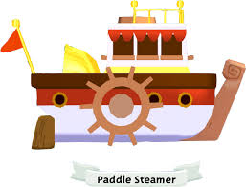

3. An empty blue bottle, not corked and 3 flags around it United Kindgdom, Germany and Chinese flags, then an arrow pointing from the UK flag to the side of the bottle (these flags are only for reference):

4. Shark sitting in a library, at a desk, reading a book, he has a sweater an glasses on, behind him are 3 long bookshelves with a sign on them saying standard, random, custom:

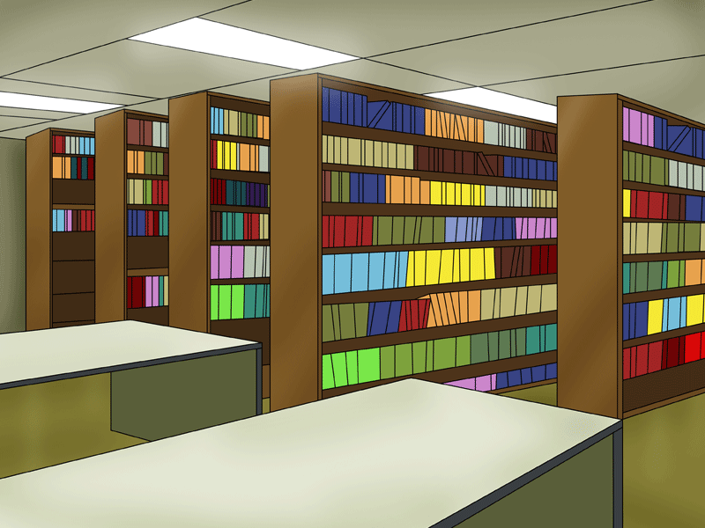

5. Shark holds a bottle in his hand (the same as in point 3. But with no flag) and speaks to it there are some sounds getting inside of the bottle, he is holding his hand in a way that you don’t see the flag that is glued on the side:

6. Picture of the bottle being in water (it was thrown there), it is corked with a brown cork, water splashes around it, we can see a sound symbol inside of it and there is also a piece of paper rolled inside of it (the flag should not be visible, as in the picture):

 -> this symbol should be inside of the bottle, together with the paper

7/8. Now we have a picture of the world map, it is bigger than this one, no countries are visible, just yellow like this, we see the bottle travelling somewhere from Europe to somewhere in Asia (from the Baltic sea to China) there is an arrow pointing it’s direction / Picture 8. Exactly the same but the arrows point the other direction: from Asia to Europe:

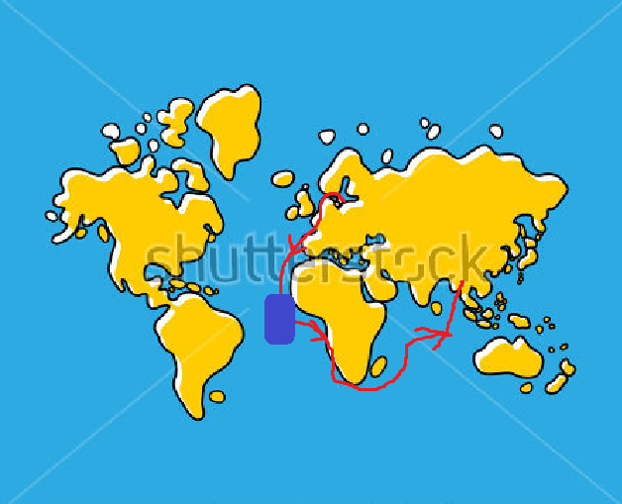

9. We have a beach, yellow sand on which several (5) bottles with bottles with messages are visible -> they are buried in the sand, in the background we see a dark shape of a shark that is approaching the beach.

10. The same shark, but having a different face, wearing Chinese clothing: listens to the bottle, he holds it at his ear, in the other hand he holds the piece of paper and reads it.

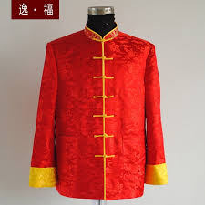

11. The first shark receives the same bottle, he is very happy, he holds it at his ear, he listens to it and reads the paper from it.

12. Picture with a list of bottles, some of them are corked, some of them are uncorked, all of them have a piece of paper inside and a sound symbol and a flag glued to the side, there are some signs next to them but you cannot recognize what they say, there are also some small avatars of sharks right side of the signs:

--6 Small pictures, icons for panels / like on duolingo website <https://nl-nl.duolingo.com/jobs>

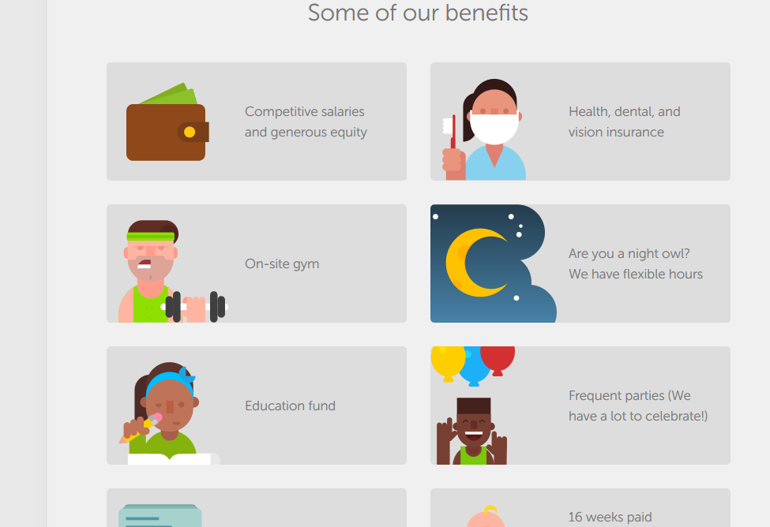

13. Confidence – shark wearing sunglasses, leather jacket with a smile



14. Fun – Shark talking with a turtle, an octopus and a fish, he stands on the left side, the rest is on the other side

15. Presentation skills – shark wearing a suit, speaking from a podium



16. Handling stress: shark is wearing a white suit, eyes closed, he is meditating, he looks relaxed



17.Creativity: shark is talking, he is smilling, there are 4 clouds around him: like in comics, they are white and black around – so that you can put a picture inside



18. Motivation – shark is walking fast, through a city, he is wearing a suit and a tie – like a businessman, he holds a briefcase in one hand, in the other he holds a phone and the talks through it

19. Picture of the shark using the language shark website on his phone, we see his back, he is holding a phone and on the phone it says: language shark

20. Shark is building a wall, but the pieces, blocks do not fit together, it is falling apart, he looks worried

21. Shark has built a wall it is big and looks perfect, it is shiny, he stands proud

22. Shark is talking with a turtle, the turtle has an evil, nasty look in his face, as if he has made a joke of the shark. Shark is looking scared, scared eyes, he doesn’t know what to say. There is a cloud coming out of his head – it is white an empty. Turtle on the left side, shark on the right.

23. Shark is talking with a turtle – this time he is confident, smiling, he is answering something, his eyes are closed and he looks smart. The turtle is surprised, his mouth is open, he doesn’t know what to say. Turtle on the left side, shark on the right.

24. For the bottom of the page: a smiling shark waving to us and pointing down (to a register button)

Reference sharks:

  